

**Assignment 5 – Interface Design Documentation**

**Systems Development Process**

**AIT 610**

**MICA Health Solutions**

Yi-Jiun Chen, David Amoo, John Rhyan Ilacas,

Chinonso Maduabuchi

November 25, 2024

Instructor: Jeffrey Tirschman

**TABLE OF CONTENTS**

1 UI Designs 3

1.1 Homepage 3

2 Login 5

3 Services Tab 6

4 Providers tabs 7

5 Schedule an Appointment 8

6 Patient Record 9

7 My Account 10

8 Payment Options 11

9 Payment Online Milepost 12

2 Database Dictionary 13

# 1 UI Designs

## 1.1 Homepage

**Functionality:**

* The homepage displays the header on all pages throughout the site which includes:
  + Logo – the clickable logo takes the user back to the homepage
  + Services – the service tab displays the different services available for customers
  + Providers – the provider tab generates a list of providers based on the criteria the user inserts
  + Records – the records tab displays different information based on the user:
    - Customer – only has the access to view own record
    - Provider – can access all records
  + Payment – the payment tab provides different options for users to pay medical bills
  + Search bar – a search engine for users to utilize to find information quickly
  + Login – this will show “login” until the user inputs their credentials to access their profile. Once logged in, this will change into “logout” for users to click to end their session.
  + FAQ – this tab lists the top questions that users ask
* The homepage’s body includes different main content that when users click brings them to the corresponding article. In this section, there is also a shortcut to schedule an appointment.
* The footer of the homepage includes contact information like phone number, email address, and mailing address for MICA Healthcare Solutions.

**Tool Tips:**

* None

**Input Validation:**

* None

**Error Messages:**

* When the user tries to access the website without the internet the following message will appear:

“No internet connection, please check your internet connection and try again.”

* When the user tries to access the website and it is down for maintenance, the following message will appear:

“Service currently unavailable, please try again later.”

## 2 Login

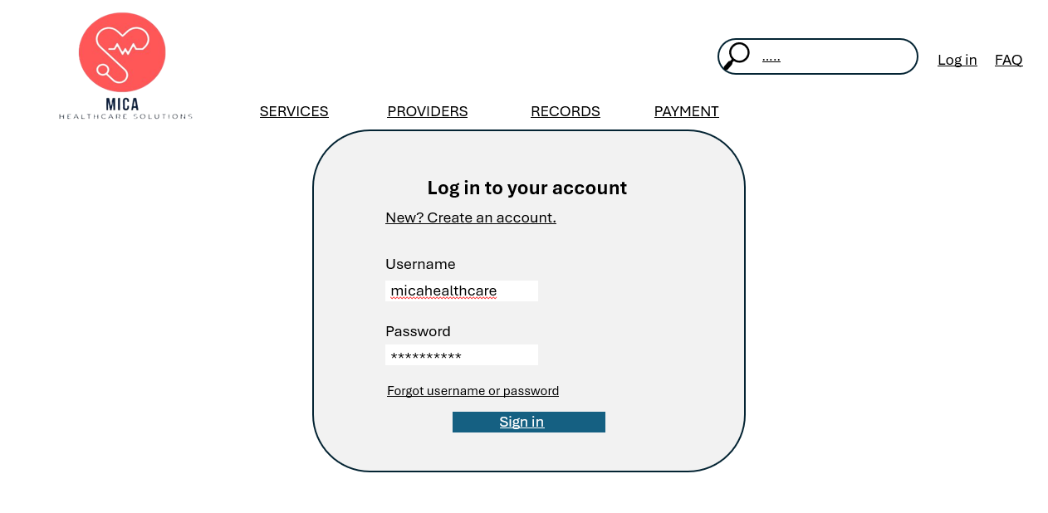

**Functionality:**

* This will allow users to securely access personalized features and content by verifying their identity. “Forward username or password” is available for users to use if it is needed. For new users, they can click “New? Create an account” to be directed to another page for them to create an account.

**Tool Tips:**

* Username field: “Enter your registered email address.”
* Password field: “Enter your secured password, password is case sensitive.”
* Login button: "Click to sign in to your account.”
* Forgot username or password: “Click here to recover username or reset password.”

**Input Validation:**

* Username: Must be a valid email format (e.g, [user@example.com](mailto:user@example.com)).
* Password: Minimum 8 characters, must contain at least one uppercase letter, one special symbol, and one number.

**Error Messages:**

* When the user inputs the wrong username or password, the following message will appear:

“Invalid username or password, please try again.”

* When a new user creates a password that does not meet the password requirement, the following message will appear:

“Password does not meet the required format, please try again.”

* When the user attempts to log in more than five times and keeps failing, the following message will appear:

“Your account is locked due to multiple unsuccessful login attempts, please try again in 24 hours. If you need help accessing your account, you can call the customer service number.”

## 3 Services Tab

**Functionality:**

* This tab will display the different services being provided. The user can learn more information about the service by clicking on them and they also have the ability to schedule an appointment.

**Tool Tips:**

* None

**Input Validation:**

* None

**Error Messages:**

* When a user tries to access this page and the service is currently unavailable, the following message will appear:

**“**Service details currently unavailable, please check back later.”

## 4 Providers tabs

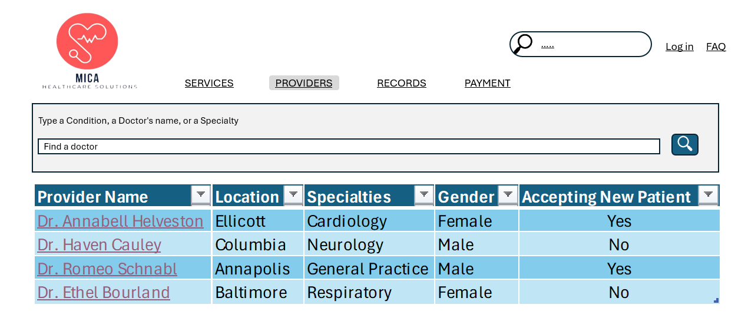

**Functionality:**

* Users will be able to search for a provider using different filters such as location, specialty, gender, and availability.
* Users will also be able to view the provider’s basic information along with their location of practice.

**Tool Tips:**

* Specialty Dropdown: “Select provider’s area of expertise.”
* Location Filter: “Enter city or ZIP code.”

**Input Validation:**

* Location: Must be a valid city name or 5-digit ZIP code.

**Error Messages:**

* When the user inputs a filter that results in zero providers, the following message will appear:

“No providers found for the selected filters, please adjust your search and try again.”

## 5 Schedule an Appointment

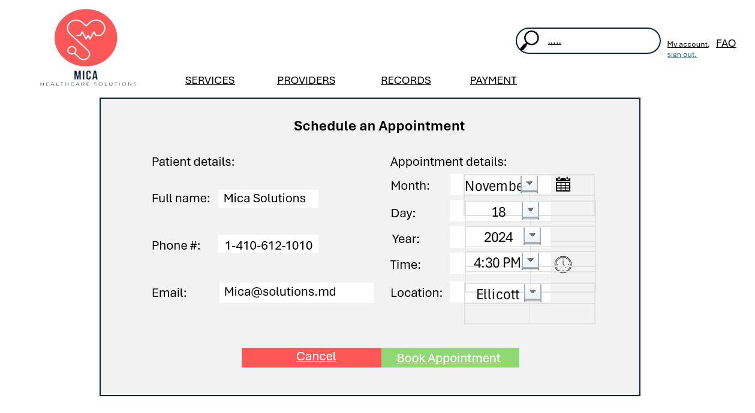

**Functionality:**

* Users will be able to schedule an appointment with date and time selection. Upon scheduling, users will also be able to cancel any scheduled appointment or reschedule an appointment.

**Tool Tips:**

* Date Selection: “Choose a preferred date for your appointment.”
* Time Slot Selection: “Select an available time slot.”

**Input Validation:**

* Date: This cannot be a past date and must be within the scheduling range.
* Time: Valid only if within the provider’s availability.

**Error Messages:**

* When the user tries to book an appointment that is not available, the following message will appear:

“Selected date/time is not available, please choose another slot.”

* When the user tries to select a past date, the following message will appear:

“Invalid date selection, please select a valid date.”

## 6 Patient Record

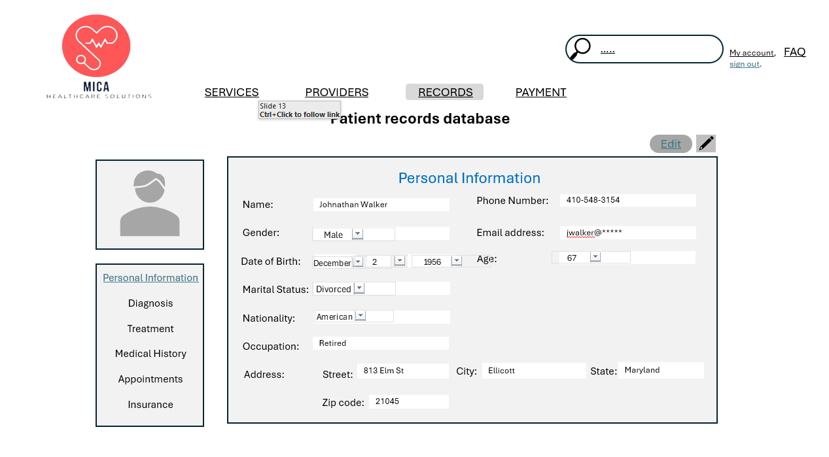

**Functionality:**

* This tab displays different information based on the user’s access permission.
  + Customers – can only view their own record
  + Providers – can view all records
* Displays patient’s health records including personal information, diagnosis, treatment plan, medical history, and insurance information.
* Users can view and edit information on these fields.

**Tool Tips:**

* Each Record Entry: “Click to view details of this record.”
* Edit button: “Click to make any adjustment on the record.”

**Input Validation:**

* None

**Error Messages:**

* When the user tries to view a record that is currently being updated, the following message will appear:

“The patient’s record is currently unavailable, please try again later. If the issues continue to persist, please contact your IT department.”

## 7 My Account

**Functionality:**

* View Chart, Lab Results, and Request Medical Records.
* View and Schedule Appointment.
* View messages, create messages.
* View billing history, make payments.

**Tool Tips:**

* Clickable icon serves as shortcuts.

**Input Validation:**

* None

**Error Messages:**

* When the user tries to access their account while the website is down, the following message will appear:

“Service currently unavailable, please try again later.”

**Functionality:**

* The user can pick from the following options to pay their medical bills. They can either pay it online through their MICA account, by phone by calling the number listed, or by mail by sending it to the following mailing address.

**Tool Tips:**

* Each Bill Item: “Click to view details about this invoice.”

**Input Validation:**

* None

**Error Messages:**

* When the invoice is unavailable, the following message will appear:

“Billing information not found, please contact customer support.”

## 9 Payment Online Milepost

**Functionality:**

* Payment gateway integration to pay bills, save payment methods, view payment status.

**Tool Tips:**

* Credit Card Field: “Enter your credit card number”
* CVV Field: “Enter the 3-digit code located in the back of your card.”

**Input Validation:**

* Credit Card Number: Must be a valid 16-digit number.
* CVV: Must be 3 digits.
* Expiration Date: This cannot be a past date.

**Error Messages:**

* When the user inputs an invalid credit card number, the following message will appear:

“Invalid credit card number, please enter a 16-digit number.”

* When the user tries to pay with a card that has insufficient balance, the following message will appear:

“Transaction failed, please try again with a different payment method.”

# 2 Database Dictionary

|  |  |  |  |  |
| --- | --- | --- | --- | --- |
| **Entity** | **Attribute** | **Description** | **Type** | **Size** |
| **Patient** | PatientID  (Primary Key) | Unique identifier for each patient. | Number (Auto-Generate) | 10 |
|  | FullName | Patient's full name which comprises of Last Name and First Name | Variable Character | 50 |
|  | DOB | Patient's date of birth. | Date | 10 |
|  | Gender | Patient's gender. The domain for this entity is Female, Male | Variable Character | 6 |
|  | Address | Patient's address. | Variable Character | 50 |
|  | PhoneNumber | Patient's phone number. | Number | 10 |
|  | EmailAddress | Patient's email address. | Variable Character | 50 |
|  | EmergencyContactInfo | Information for the patient's emergency contact. | Variable Character | 50 |
|  | MedicalHistory | Summary of the patient's medical history. System generated from the medical notes from health providers | Variable Character | 250 |
|  | InsuranceProvider | Name of the patient's insurance provider. | Variable Character | 50 |
|  | PolicyNumber (Foreign Key – Insurance Table) | Patient's insurance policy number. | Number | 10 |
|  | GroupNumber | Group number for the insurance policy. | Number | 10 |
|  | CoverageDetails | Details about insurance coverage. | Variable Character | 250 |
|  | | | | |
| **Appointment** | AppointmentID (Primary Key) | Unique identifier for an appointment made | Number (Auto-Generated) | 10 |
|  | PatientID (Foreign Key – Patient Table) | Link to the patient's record | Number | 10 |
|  | AppointmentTime | Unique identifier for the doctor | Time | 5 |
|  | AppointmentDate | Date of the appointment | Date | 10 |
|  | ProviderID  (Foreign Key – Health Providers Table) | The ID of the Health Provider assigned to the appointment | Number | 10 |
|  | MeetingMedium | Status of the appointment. The domain is Physical, Virtual | Variable Character | 10 |
|  | Status | Status of the appointment. The domain Schedule, Confirmed, Cancelled | Variable Character | 10 |
|  | | | | |
| **Provider** | ProviderID (Primary Key) | Unique identifier for each healthcare provider. | Number (Auto-Generate) | 10 |
|  | FullName | Full name of the healthcare provider which comprises of Last Name and First Name | Variable Character | 50 |
|  | Specialty | Medical specialty of the provider. The domain is Anesthesiology, Cardiology, Cardiothoracic Surgery, Dermatology, Emergency Medicine, Endocrinology, Family Medicine, Gastroenterology, Hematology, Infectious Disease, Internal Medicine, Neurology, Neurosurgery, Obstetrics and Gynecology (OB/GYN), Oncology, Ophthalmology, Orthopedic Surgery, Pediatrics, Plastic Surgery, Psychiatry  Pulmonology, Radiology, Surgery, Urology | Variable Character | 50 |
|  | PhoneNumber | Contact phone number of the provider. | Number | 10 |
|  | EmailAddress | Contact email address of the provider. | Variable Character | 50 |
|  | OfficeLocation | Location of the provider’s office. | Variable Character | 50 |
|  | | | | |
| **Medication** | MedicationID (Primary Key) | Unique identifier for each medication record. | Number (Auto-Generate) | 10 |
|  | MedicationName | Name of the medication prescribed to the patient. | Variable Character | 50 |
|  | Dosage | Dosage information (e.g., "500mg"). | Number | 4 |
|  | DosageFrequency | Frequency of medication (e.g., "Twice daily"). The domain is Once, Twice, Thrice, As Advised | Variable Character | 5 |
|  | StartDate | Date when the medication was first prescribed. | Date | 10 |
|  | EndDate | Date when the medication course ends (NULL if ongoing). | Date | 10 |
|  | CreatsDate | Date when the medication record was created. Default Date is date of entry | Date (Auto-Generated | 10 |
|  |  |  |  |  |
| **Treatment** | TreatmentID (Primary Key) | Unique identifier for treatments administered | Number (Auto-Generate) | 10 |
|  | PatientID (Foreign Key – Patient Table) | Link to the patient's record | Number | 10 |
|  | TreatmentType | Description of the treatment administered | Variable Character | 50 |
|  | TreatmentDate | Date when the treatment was provided | Date | 10 |
|  | Cost | Cost of the treatment received | Number | 10 |
|  | | | | |
| **Payment** | PaymentID (Primary Key) | Unique identifier for each payment transaction. | Number (Auto-Generate) | 10 |
|  | PatientID (Foreign Key – Patient Table) | Links to the patient making the payment. | Number | 10 |
|  | PaymentAmount | Amount paid by the patient. | Number | 10 |
|  | PaymentDate | Date and time when the payment was made. | Time Stamp with Date | 15 |
|  | PaymentMethod | Method of payment. The domain is Credit Card, Cash, Insurance). | Variable Character | 10 |
|  | PaymentStatus | Status of the payment transaction. The domain is Not Started, In-Progress, Processed, Refunded | Variable Character | 10 |
|  | CreatedDate | Date when the payment record was created. Default is current date | Date (Auto-Generate) | 10 |
|  | | | | |
| **LabTest** | TestID (Primary Key) | Unique identifier for each lab test. | Number (Auto-Generate) | 10 |
|  | CollectionDate | Date when the specimen was collected from the patient. Default is current date | Date (Auto-Generate) | 10 |
|  | CompletionDate | Date when the test was completed and results were generated. | Date | 10 |
|  | SpecimenType | Type of specimen collected for the test (e.g., blood, urine, tissue). The domain is Blood Specimen, Urine Specimen, Tissue Specimen, Sputum Specimen, Swab Specimen, Stool Specimen, Cerebrospinal Fluid Specimen, Synovial Fluid Specimen, Saliva Specimen, Hair and Nail Specimen | Variable Character | 20 |
|  | PatientID (Foreign Key – Patient Table) | Links to the Patient table; identifies the patient undergoing the test. | Number | 10 |
|  | ProviderID (Foreign Key – Provider Table) | Links to the Provider table; identifies the healthcare provider who ordered the test. | Number | 10 |
|  | Etiology | Underlying cause or reason for conducting the test (e.g., suspected condition, diagnosis). | Variable Character | 50 |
|  | Results | Findings or outcomes of the lab test (e.g., positive, negative, numerical values as per the test type). | Variable Character | 50 |
|  | | | | |
| **Insurance** | PolicyNumber (Primary Key) | Unique identifier for the insurance policy associated with the patient. | Number (Auto-Generate) | 10 |
|  | CompanyName | Name of the insurance company providing the policy. | Variable Character | 50 |
|  | CompanyAddress | Address of the insurance company’s main office or branch relevant to the policy. | Variable Character | 250 |
|  | PlanType | Type of insurance plan (e.g., HMO, PPO, EPO) under which the patient is covered. The domain is Health Maintenance Organization, Preferred Provider Organization, Exlusice Provider Organization, Point of Service  High Deductible Health Plan, Catastrophic Health Insurance, Medicare, Medicaid, Indemnity Plans | Variable Character | 50 |
|  | PolicyEffectiveDate | Date when the insurance policy became effective for the patient. | Date | 10 |
|  | PatientID (Foreign Key – Patients Table) | Links to the Patient table; identifies the patient covered under the insurance policy. | Number | 10 |

# 3 Contribution Summary

|  |  |  |
| --- | --- | --- |
| **Deliverables** | **Responsibilities** | **Team member** |
| Application Screen Design | Interface screen creation | John/David |
|  | Interface structure diagram | John/Chinonso |
|  | Database elements integration | John/Yi-Jiun |
|  | Documentation in Word | John/Yi-Jiun |
| Report Specifications | Lab test result | John |
|  | Patient care report | John |
|  | Medical invoice | Chinonso |
|  | Appointment scheduling report | Chinonso |
|  | Patient satisfaction survey summary report | Yi-Jiun |
| Application Test Plan | Test plan template completion | David |
| Database Dictionary | Define all entities and attributes | Yi-Jiun |
|  | Define all types and sizes | David |